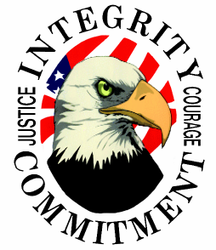
Eastern Missouri Police Academy
11 Meadows Circle Drive Suite 422
Lake St. Louis, MO 63367

Confrontation to Cooperation: Words as Tools for Traffic Stops
June 5, 2025 at Maryland Heights Police Department (City Council Chambers)
8:00 am – 5:00 pm
Practical Weather Attire Recommended

This course is designed to identify the appropriate initial contact procedures with a motorist on a traffic stop, and to recognize pre-traffic stop and during the traffic stop indicators of resistance by the motorist and/or passengers. Ultimately, techniques for de-escalation will be taught, along with identifying when those techniques can/should be used. Communication barriers an officer may experience during a traffic stop will also be addressed, along with tactical communication strategies that can be used for the best outcome. Recognition will also be given for how successful traffic stops can enhance community relations and enhance legitimacy of the officer, their respective agency, and policing as a profession. Attendees will also demonstrate best practices and tactics during simulated traffic stops from preplanned scenarios.

Participants will receive 8 hours of training in the following categories: 2 hrs Interpersonal Perspectives, 6 hrs Skill Development

Course is FREE for ALL Attendees, MODOT Highway Safety Funded.

For additional information or to register, please contact:
Training Director, Crystal Rinkel at (636) 614-4072 or e-mail crinkel@thepoliceacademy.org

